DRUMAHOE
PRIMARY
SCHOOL

SAFEGUARDING

&

CHILD PROTECTION

POLICY

CONTENTS

Introduction | Page 3
Child Protection Principles | Page 3
Roles & Responsibilities | Page 3 - 6
Definition of Harm | Page 6
Dealing with Disclosures of Abuse | Pages 6-7
Procedures for Reporting Suspected or Disclosed Child Abuse | Pages 7-8
Allegations | Page 8
Confidentiality | Page 9
Record Keeping | Page 9
Safeguarding in the Curriculum | Page 10
Vetting Procedures | Page 10
Staff In-Service Training | Page 11
Monitoring and Evaluation | Page 11
Useful Contact Numbers | Page 11
Appendices:  - Code of Conduct for All Staff  - Code of Conduct for Visitors  - Procedure for Parents to raise a Child Protection Concern  - Procedure where the school has concerns or has been given information about possible abuse by someone other than a member of staff.  - Procedure where a complaint has been made about possible abuse by a member of the school’s staff.  - Out of School Activities / School Visit Pro-forma  - Photographic Consent Form  - Acceptable Use Agreement- Staff, Governors and Visitors  - Acceptable Use Agreement- Pupils  - Temporary Administration of Medication  - Changing Procedures for Children with Special Educational Needs & Intimate Care Recording  - The School Safeguarding Team - Roles & Responsibilities  - Child Protection Record – ‘Note of Concern’  - Types of Abuse and Physical/Behavioural Indicators | Pages 12-40

INTRODUCTION

Child Protection Ethos … “Our school is about developing the potential of everyone to the full, within a caring and stimulating environment.”

We in Drumahoe Primary School have a responsibility for the Pastoral Care, general welfare and safety of the children in our care and we will carry out this duty by providing a caring, supportive and safe environment, where each child is valued for his or her unique talents and abilities, and in which all our young people can learn and develop to their full potential. All staff, teaching and non-teaching should be alert to the signs of possible abuse and should know the procedures to be followed. This Policy sets out guidance on the action, which is required where abuse or neglect of a child is suspected and outlines referral procedures within our school

The staff at Drumahoe Primary School has adopted a Code of Conduct (See Appendix 1) and visitors are required to read and adhere to The Visitors Code of Conduct, sign the visitors’ book and wear a visitors’ badge (See Appendix 2).

Child Protection Principles

The general principles, which underpin our work, are those set out in the UN Convention on the Rights of the Child and are enshrined in the Children (Northern Ireland) Order 1995, The Education and Libraries (NI) Order 2003 the Department of Education (Northern Ireland) guidance “Pastoral Care in Schools- Child Protection”(DENI Circular 99/10), the Area Child Protection Committees’ Regional Policy and Procedures (2005), Co- operating to Safeguard Children and Young People in Northern Ireland (2016), Safeguarding Board Act Northern Ireland (2011).

The following principles form the basis of our Child Protection Policy.
- It is a child’s right to feel safe at all times, to be heard, listened to and taken seriously.
- We have a pastoral responsibility towards the children in our care and should take all reasonable steps to ensure their welfare is safeguarded and their safety is preserved. • In any incident the child’s welfare must be paramount, this overrides all other considerations.
- A proper balance must be struck between protecting children and respecting the rights and needs of parents and families; but where there is conflict the child’s interest must always come first.

Aims to be addressed through this policy document:

- To introduce procedures in the school to deal with suspected cases of child abuse as directed by Department and EA circulars.
- To make the staff aware of the referral procedure within the school.
- To make parents aware of the procedures set up in school to deal with suspected cases of child abuse.

The appendices include Code of Conduct Guidelines for Staff and Visitors as well as information relating to internet access, use of children’s images, use of mobile phones, administration of medication and changing clothes.

The school has a duty to ensure that safeguarding permeates all activities and functions. The child protection therefore complements and supports a range of other school policies including:
- Pastoral Care Policy
- Positive Behaviour & Discipline Policy
- Anti-Bullying Policy
- Use of Reasonable Force/Safe Handling
- Special Educational Needs
- Educational Visits
- Administration of Medicines
- Health and Safety Policy
- Relationships and Sexuality Education
- Intimate Care
- Use of Mobile Phones/Cameras
- E-Safety Policy
- Attendance Policy
These policies are available to parents and any parent wishing to have a copy should contact the School office or visit the school website at: www.drumahoeps.org or in the Information Section of the School App.

Roles and Responsibilities:

Safeguarding Team

The following are members of the school’s Safeguarding Team:

- Chair of the Board of Governors (Mrs C McConnell);
- Designated Governor for Child Protection (Mrs A Holmes);
- Principal (Mrs E Walker);
- Designated Teacher (Mrs L Hegarty);
- Deputy Designated Teachers (Mrs E Walker and Mrs A Johnston).

The main role of the team is to:

- Monitor and periodically audit the safeguarding and child protection arrangements in the school
- Identify any actions required to address audit findings or ETI inspection of its safeguarding/child protection arrangements
- Provide support for the Designated and Deputy Designated teachers in the exercise of their child protection responsibilities.

The roles and responsibilities of individual members of the Safeguarding team are summarised in Appendix 12.

The Board of Governors
The Board of Governors as a body must ensure that the school fulfils its safeguarding responsibilities in keeping with current legislation and DE guidance including:
- ensuring that safeguarding/child protection is a standard item on the agenda of Board of Governor meetings;
- approving the school’s child protection policy at least once every 2 years;
- ensuring that there is a time-tabled review (every 2/3 years) of all other safeguarding policies and that they are presented to the BOG for approval;
- receiving annual child protection reports;
- ensuring there is a Staff Code of Conduct for all adults working in the school;
- attending relevant child protection/safeguarding training for Governors.

School Staff
Teachers, Classroom Assistants and other Support staff in school see children on a daily basis over long periods and can notice physical, behavioural and emotional indicators and a child may choose to disclose to them allegations of abuse.

Members of staff must refer concerns or disclosures to the Designated/Deputy Teacher (Principal) for Child Protection. In addition, class teachers should also keep the Designated Teacher informed in writing or verbally about poor attendance and punctuality, poor presentation, changed or unusual behaviour including self-harm and suicidal thoughts, deterioration in educational progress, discussions with parents about concerns relating to their child, concerns about pupil abuse or serious bullying and concerns about home circumstances including disclosures of domestic abuse.

A pro-forma for reporting a concern or disclosure is included at Appendix 13 - Child Protection Record – Note of Concern. If a member of staff does not feel their concerns are being taken seriously or action to safeguard the child is not being taken by professionals and the child is considered to be at risk of continuing harm then they should speak to the Designated Teacher for Child Protection, Principal, Education Authority Designated Officer for Child Protection or to Social Services.

Parents
Parents can play their part in safeguarding by:
- telephoning the school on the morning of their child’s absence, or sending in a note (Absence Slip) on the child’s return to school, so as the school is reassured as to the child’s well-being;
- making requests to the school in advance for permission to allow their child to attend medical or other appointment (Exeat Slip) including providing details of any arrangements for the collection of the child;
- informing the school whenever anyone, other than themselves, intends to pick up the child after school;
- familiarising themselves with the schools safeguarding policies e.g. Anti-
Bullying, Positive Behaviour, Use of Internet and Child Protection Policies;
- reporting to the school office when they visit the school;
- sharing any concern they may have in relation to their child with the school.

Definition of Harm

Harm can be suffered by a child or young person by acts of abuse perpetrated upon them by others. Abuse can happen in any family, but children may be more at risk if their parents have problems with drugs, alcohol and mental health, or if they live in a home where domestic abuse happens. Abuse can also occur outside of the family environment. Evidence shows that babies and children with disabilities can be more vulnerable to suffering abuse.

Although the harm from the abuse might take a long time to be recognisable in the child or young person, professionals may be in a position to observe its indicators earlier, for example, in the way that a parent interacts with their child. Effective and on-going information sharing is key between professionals

(Co-operating to Safeguard Children and Young People in Northern Ireland 2016)

Harm can be caused by:

- Physical abuse
- Sexual abuse
- Emotional abuse
- Neglect; and
- Exploitation

The procedures outlined in this document are intended to safeguard children who are at risk of significant harm because of abuse or neglect by a parent, carer or other with a duty of care towards a child. The main types of abuse as well as their physical and behavioural indicators are included in Appendix 14.

Dealing with Disclosures of Abuse

The following are guidelines for use by staff should a child disclose concerns of a child protection nature.

Receive - listen to what the child says, without displaying shock or disbelief. Accept what is said, making brief cursory notes. These notes should be retained.

Reassure -ensure the child is reassured that he/she will be safe and his/her interests will come first. No promise of confidentiality can or should be made to a child or anyone else giving information about possible abuse.

Respond - respond to the child only as far as is necessary for you to establish whether or not you need to refer the matter. Use open questions e.g. anything else to tell me? Do not interrogate or ask leading questions- this may invalidate your evidence and the child’s in any later court proceedings. Do not criticise the perpetrator- the child may love this person and reconciliation may be possible. Explain what you have to do next and to whom you have to talk.

Record- make notes at the time and write these up as soon as possible afterwards. Note the time, date, place, people present as well as what is seen and said. Record key phrases/words used, noticeable non-verbal behaviour and any physical injuries.
Under no circumstances should a child be photographed or a child’s clothing removed. Do not destroy original notes.

Report- refer the matter to the Designated Teacher. Respect confidentiality i.e. the matter should only be discussed on a ‘need to know basis’.

Procedures for Reporting Suspected or Disclosed Child Abuse

How a Parent can make a Complaint
We aim to work closely with parents/guardians in supporting all aspects of their child’s development and well-being. Any concerns a parent may have will be taken seriously and dealt with in a professional manner. If a parent has a concern they can talk to the Class Teacher, the Designated or Deputy Designated Teacher for child protection or the Principal. If they are still concerned they may talk to the Chair of the Board of Governors. At any time, a parent may talk to a social worker in the local Gateway team or to the PSNI Public Protection Unit. Details of who to contact are shown in the flowchart in Appendix 3.

Where the school has concerns or has been given information about possible abuse by someone other than a member of the school staff including volunteers.
If a child makes a disclosure to a teacher or other member of staff which gives rise to concerns about possible abuse, or if a member of staff has concerns about a child, the member of staff must act promptly. He/she should not investigate- this is a matter for Social Services- but should report these concerns immediately to the Designated Teacher (if she is not available the Deputy Designated Teachers) and discuss the matter with her, and make full notes.

These notes or records should be factual, objective and include what was seen, said, heard or reported. They should include details of the place and time and who was present and should be given to the Designated/Deputy Designated Teachers. The person who reports the incident must treat the matter in confidence.

The Designated/Deputy Designated Teacher will decide whether in the best interest of the child the matter needs to be referred to Social Services. He/she will discuss the matter with the Principal and may also seek advice or clarification from the Education Authority Designated Officer for Child Protection or from Social Services (Gateway Team). Where it is evident that a young person has been or is at risk of being abused and/or a criminal offence may have been committed then the school must make a referral.

Referrals to Social Services will be made by telephone in the first instance and within 24 hours will be followed by the completion of a UNOCINI (Understanding the Needs of Children in Northern Ireland) referral form. If a referral is made a copy of the UNOCINI referral form should be sent to the Education Authority Designated Officer for Child Protection. A copy of the UNOCINI form will be placed in the school’s child protection file.

This procedure with names and contact numbers is shown in Appendix 4 - procedure where the school has concerns, or has been given information about possible abuse by someone other than a member of staff.

Where a complaint has been made about possible abuse by a member of the school’s staff or a Volunteer
When a complaint about possible child abuse is made against a member of staff the Principal (or the Designated Teacher if the Principal is not available) must be informed immediately. If the complaint is against the Principal, then the Designated Teacher should be informed and he/she will inform the Chairperson of the Board of Governors who will consider what action is required in consultation with the employing authority.

The procedure as outlined in Appendix 5 - procedure where a complaint has been made about possible abuse by a member of the school’s staff will be followed in keeping with current Department of Education guidance (DE Circular 2015/13).

NOTE: In all cases of suspected child abuse, the action to be taken by the school is that of informing Social Services and the Education Authority. The school will NOT be involved in investigating the suspected abuse.

Allegations:

Allegation against a member of staff
If a complaint about possible child abuse is made against a member of staff, Mrs Walker (Principal) and Mrs Hegarty (DT) must be informed immediately. Parents can also seek advice from the School’s Designated Child Protection Governor, Mrs A Holmes. The above procedures will apply unless the complaint has been made about the Principal/DDT or Vice Principal/DT).

Allegation against the Principal
If the complaint is made against the Principal, Mrs Hegarty must be informed immediately. Mrs Hegarty will inform the Chairperson (Mrs C McConnell) and together they will ensure that the necessary action is taken.

Suspension from Duty
Where the matter has been referred to the Social Services and or PSNI, the member of staff will be removed from duties involving direct contact with pupils, and may be suspended from duty as a precautionary measure pending investigation by Social Services. The Chairman of the Board of Governors will be informed immediately.

Attendance at Child Protection Case Conferences and Other Social Services Meetings
The Designated Teacher/Deputy Designated Teacher or Principal may be invited to attend an initial and review Child Protection Case Conferences, core group or family support planning meetings convened by the Health & Social Care Trust. They will provide a written report which will be compiled following consultation with relevant staff.
Feedback will be given to staff under the ‘need to know ’principle on a case-by-case basis. Children whose names are on the Child Protection register will be monitored and supported in accordance with their child protection plan.

Consent from Pupils and Parents
Prior to making a referral to Social Services the consent of the parent/carers and/or the young person (if they are competent to give this) will normally be sought. The exception to this is where to seek such consent would put that child, young person or others at increased risk of significant harm or an adult at risk of serious harm, or it would undermine the prevention, detection or prosecution of a serious crime including where seeking consent might lead to interference with any potential investigation.

In circumstances where the consent of the parent/carer and/or the young person has been sought and is withheld we will consider and where possible respect their wishes. However, our primary consideration must be the safety and welfare of the child and we will make a referral in cases where consent is withheld if we believe on the basis of the information available that it is in the best interests of the child/young person to do so.

Confidentiality and Information Sharing
Information given to members of staff about possible child abuse cannot be held “in confidence”. In the interests of the child, staff have a responsibility to share relevant information about the protection of children with other professionals particularly the investigative agencies. In keeping with the principle of confidentiality, the sharing of information with school staff will be on a ‘need to know’ basis. Should a child transfer to another school whilst there are current child protection concerns we will share these concerns with the Designated Teacher in the receiving school.

For reasons of confidentiality the only people who need to know details of suspected cases are:
- Mrs E Walker, Principal/Mrs A Johnston - Deputy Designated Teachers
- Mrs L Hegarty, Designated Teacher
- Chair of the Board of Governors & Designated Governor for Child Protection

Other members of staff need to know only enough to prepare them to act with sensitivity to a distressed pupil. They do not need to know detail.

Record Keeping
All child protection records, information and confidential notes are stored securely and only the Designated Teacher/Deputy Designated Teacher and Principal have access to them. In accordance with DE policy on the disposal of child protection records these records will be stored from child’s date of birth plus 30 years as per (DE Circular 2016/20 Child Protection: Record Keeping in Schools).

Staff will make notes at the time of the disclosure on the school pro-forma (Appendix 13) as soon as possible. The date, time, place, any noticeable non-verbal behaviour and the words used by the child will be recorded. If the child uses sexual ‘pet’ words, the actual words used will be recorded rather than translating them into ‘proper’ words. Any injuries or bruises noticed will be recorded on a diagram (‘Body Map’) showing position and extent. Under no circumstances will a child’s clothing be removed. Staff will be made aware that their note of the discussion might need to be used in any subsequent court proceedings

All records, information and confidential notes will be kept in separate files in the locked Safeguarding File Box. These will only identify the child by their initials and date of birth. These records are kept separate from the child’s individual report.
Where an allegation is made against a member of staff and is pursued either as a formal referral or under the school’s disciplinary procedures, a summary is entered on a Record of Abuse Complaints Notebook. This entry, which will contain details
of the complaint, is stored in the locked Safeguarding Drawer, and will be made available to the Board of Governors at least annually and signed by the Chair and Principal if appropriate.

In addition to the above, the school specifically recognises the need to protect children when:
- On school trips;
- Using the internet;
- Administering medication;
- Changing wet or soiled clothes.

For this reason, the school will request parental consent on:

- All out of school activities (See Appendix 6);
- Photographic Consent Form (GDPR) (Appendix 7);
- Access to the internet (See Appendices 8 and 9);
- Administration of medication (See Appendix 10);
- Changing procedures (See Appendix 11).

Operation Encompass

We are an Operation Encompass school. Operation Encompass is an early intervention partnership between local Police and our school, aimed at supporting children who are victims of domestic violence and abuse. As a school, we recognise that children’s exposure to domestic violence is a traumatic event for them.

Children experiencing domestic abuse are negatively impacted by this exposure. Domestic abuse has been identified as an Adverse Childhood Experience and can lead to emotional, physical and psychological harm. Operation Encompass aims to mitigate this harm by enabling the provision of immediate support. This rapid provision of support within the school environment means children are better safeguarded against the short, medium and long-term effects of domestic abuse.

As an Operation Encompass school, when the police have attended a domestic incident and one of our pupils is present, they will make contact with the school at the start of the next working day to share this information with a member of the school safeguarding team. This will allow the school safeguarding team to provide immediate emotional support to this child as well as giving the designated teacher greater insight into any wider safeguarding concerns.

This information will be treated in strict confidence, like any other category of child protection information. It will be processed as per DE Circular 2020/07 ‘Child Protection Record Keeping in Schools’ and a note will be made in the child’s child protection file. The information received on an Operation Encompass call from the Police will only be shared outside of the safeguarding team on a proportionate and need to know basis. All members of the safeguarding team will complete online Operation Encompass training, so they are able to take these calls. Any staff responsible for answering the phone at school will be made aware of Operation Encompass and the need to pass these calls on with urgency to a member of the Safeguarding team.

Further information see The Domestic Abuse Information Sharing with Schools etc. Regulations (Northern Ireland) 2022.

Safeguarding in the Curriculum
The school seeks to promote pupils’ awareness and understanding of safeguarding issues, including those related to child protection through its curriculum. The safeguarding of children is an important focus in the school’s personal development programme and is also addressed where it arises within the context of other subjects. Furthermore, school posters/displays include information directing a pupil on how to seek help, advice and support within the school and from external agencies and professionals.

Vetting Procedures
All staff paid or unpaid who are appointed to positions in Drumahoe Primary School are vetted / supervised in accordance with relevant legislation and Departmental guidance. Staff such as teaching and non-teaching, including parent volunteers, students on work experience, external coaches and music tutors, will be subject to vetting procedures through Access NI before permission is granted to work in the school, either on a paid or voluntary basis. Copies of Access NI Certificates will be kept in the Secretary’s Office.

Code of Conduct for all Staff Paid or Unpaid
All actions concerning children and young people must uphold the best interests of the young person as a primary consideration. Staff must always be mindful of the fact that they hold a position of trust and that their behaviour towards the child and young people in their charge must be above reproach.

All members of staff are expected to comply with the school’s Code of Conduct for Employees and Volunteers which is included as Appendix 1 to this policy.

Staff Training
All staff will receive basic child protection awareness training and regular refresher training. Each member of staff will receive the general training on this policy and the procedures once every two years. This will be led by the Designated Teacher for Child Protection. The Designated Teacher and deputy Designated Teacher will also avail of courses offered by the EA and other multi-disciplinary agencies. When new staff or volunteers start at the school they are briefed on the school’s Child Protection Policy and Code of Conduct and given copies of these policies.

The Principal, Designated Teacher/Deputy Designated Teachers, Chair of the Board of Governors and Designated governor for Child Protection attend training courses specific to their roles which is provided by the Education Authority’s Child Protection Support Service for Schools.

Monitoring and Evaluation
The Safeguarding Team will discuss all current Child Protection issues on a termly basis or if and when required. The Board of Governors (who have reviewed and approved this policy) will also be advised of relevant Child protection issues at regular intervals during the course of the school year. Specific details will not be shared with the Governors and confidentiality will be maintained. The Safeguarding Team will review this policy annually and advise Governors and parents of changes when necessary. All parents will receive a summary (in the form of a tri-fold pamphlet) once every two years outlining the basic Child Protection Procedures and Policy.

The policy will be implemented through the school’s staff induction and training programme and as part of day to day practice. Compliance with the policy will be monitored on an on-going basis by the Designated Teacher for Child Protection and periodically by the Schools Safeguarding Team.

Date of Next Review: February 2023

Signed: (Chair of Board of Governors) ____________________________

(Principal) _________________________

USEFUL CONTACT NUMBERS

EA Child Protection Officers:  Marion McBride  Martin McQuaid  Patricia Houston | 028 82411289
Western Health & Social Care Trust Gateway Team | 028 71314090
PSNI Public Protection Unit  PSNI C.A.R.E. Unit (Maydown) | 0845 600 8000  02870344122
Childline | 0800 1111
NSPCC | 0800 800 5000
APPENDIX 1 – CODE OF CONDUCT FOR ALL STAFF

This Code of Conduct is for employees within the education sector whose work brings them into contact with children/young people. The ‘Code’ is intended to assist staff in respect of the complex issue of child abuse, by drawing attention to the areas of risk for staff and by offering guidance on prudent conduct. It is built on the premise that staff must always be mindful of the fact that they hold a position of trust, and that their behaviour towards the children and young people in their charge must be above reproach. This Code of Conduct is not intended to detract from the enriching experiences children and young people gain from positive interaction with staff within the education sector.

Private Meetings with Pupils

- Staff should be aware of the possible misconceptions or potential risks which may arise from private interviews with individual pupils. It is recognised that in the normal course of school life there will be occasions when confidential interviews must take place. As far as possible, staff should conduct such interviews in a room with visual access, or with the door open.
- Where such conditions cannot apply, staff are advised to ensure that another adult knows that the interview is taking place. While it may be appropriate to use a sign indicating that the room is in use it is not advisable to use signs prohibiting entry to the room.
- If a member of staff has concerns that a private interview with a pupil may be misinterpreted or may give rise to concern he or she should ensure that another adult (or if this is not possible another pupil) is present or nearby.
- Staff should be mindful of the potential risks involved in the use of social networking sites accessed by pupils.

Physical Contact with Pupils

Staff should not feel inhibited from responding to the needs of the child and offering comfort as a caring parent would provide. However, this should only occur when the child is in agreement.

- As a general principle, all staff are advised not to make unnecessary physical contact with their pupils.
- It is unrealistic and unnecessary, however, to suggest that staff should touch pupils only in emergencies. In particular, a distressed child, especially a younger child, may need reassurance involving physical comforting, as a caring parent would provide. Staff should not feel inhibited from providing this.
- Staff should never touch a child who has clearly indicated that he/she is, or would be, uncomfortable with such contact, unless it is necessary to protect the child, others or property from harm.
- Physical punishment is illegal, as is any form of physical response to misbehaviour, unless it is by way of necessary restraint.
- Staff who need to administer first-aid to a pupil should ensure wherever possible that this is done in the presence of other children or another adult. However, no member of staff should hesitate to provide first-aid in an emergency simply because another person is not present.
- Any physical contact which would be likely to be misinterpreted by the pupil, parent or other casual observer should be avoided.
- Following any incident where a member of staff feels that his/her actions have been, or may be, misconstrued, a written report of the incident should be submitted immediately to the Principal and Vice-Principal (Designated Teacher).
- Staff should be particularly careful when supervising pupils in a residential setting, or in approved out of school activities, where more informal relationships tend to be usual and where staff may be in proximity to pupils in circumstances very different from the normal school/work environment.

Restraint

Staff should only use reasonable force when absolutely necessary:
- To prevent injury to the child, other children, themselves or another member of staff.
- To prevent damage to school property.
- To prevent the commission of an offence.
- The rights of a member of staff to use reasonable force to restrain a pupil applies on the premises of the school or elsewhere at a time when he/she has lawful control or charge of the pupil concerned.
- Staff should inform the Principal after any incident where reasonable force has been used and record the incident on the appropriate form (RF1) – see Use of Reasonable Force Policy.
- There should be a written account made of the incident in order to prevent any misunderstanding or misinterpretation. The account should include the names of those involved, when and where the incident took place, names of witnesses, a brief account of the steps taken to defuse the situation and the outcome of the incident.

Choice and Use of Materials

- Teachers should avoid teaching materials, the choice of which might be misinterpreted and reflect upon the motives for the choice.
- When using teaching materials of a sensitive nature a teacher should be aware of the danger that their application, either by pupils or by the teacher, might after the event be criticised.
- If in doubt about the appropriateness of a particular teaching material, the teacher should consult with the Principal before using it.

Relationships and Attitudes

Staff should ensure that their relationships with pupils are appropriate to the age, maturity and sex of the pupils, taking care that their conduct does not give rise to comment or speculation. Attitudes, demeanour and language all require care and thought, particularly when staff are dealing with adolescent boys and girls.

Handling Conversations of a Sensitive Nature

- Listen and accept information.
- Take notes, explaining to the child why you are doing so.
- Reassure the child.
- Do not make promises about the future.
- Refer the conversation to the Safeguarding Team ref. ‘Note of Concern Report’.

Photographic Images

- With the written consent of parents, on behalf of pupils, the school permits the appropriate taking of images by staff and pupils with school equipment.
- Staff are not permitted to use personal digital equipment, such as mobile phones and cameras, to record images of pupils, this includes when on field trips. However, with the express permission of the Principal, images can be taken provided they are transferred immediately and solely to the school’s network and deleted from the staff device.

E-Safety & Internet Use

- Staff must exercise caution when using information technology and be aware of the risks to themselves and others. Regard should be given to the schools’ ESafety and ICT Acceptable Use Policy at all times.
- Staff must not engage in inappropriate use of social network sites which may bring themselves, the school, school community or employer into disrepute. Staff should ensure that they adopt suitably high security settings on any personal profiles they may have.
- Staff should exercise caution in their use of all social media or any other web based presence that they may have, including written content, videos or photographs, and views expressed either directly or by ‘liking’ certain pages or posts established by others.
- Contact with students should only made via the use of school email accounts or telephone equipment when appropriate.
- Photographs/stills or video footage of students should only be taken using school equipment, for purposes authorised by the school. Any such use should always be transparent and only occur where parental consent has been given. The resultant files from such recording or taking of photographs must be stored in accordance with the school’s procedures.
- Teachers should supervise access to Internet resources (where reasonable) through the school’s fixed and mobile internet technology.
- Teachers will preview any recommended sites before use.
- Raw image searches are discouraged when working with pupils.
- If Internet research is set for homework, specific sites will be suggested that have previously been checked by the teacher. It is advised that parents re-check these sites and supervise this work. Parents will be advised to supervise any further research.

Personal Mobile Devices (– see also Mobile Phone policy)
The school allows staff to bring in personal mobile phones and devices for their own use. Under no circumstances does the school allow a member of staff to contact a pupil or parent/ carer using their personal device.

- The sending of inappropriate text messages between any member of the staff is not allowed.
- Permission must be sought before any image or sound recordings are made on these devices of any member of staff.
- Staff bringing personal devices into school must ensure there is no inappropriate or illegal content on the device.

Intimate Care and S.E.N. – see also Intimate Care Policy
You may be required to provide intimate care for children who have special educational needs. The following guidelines must be followed:

- Ensure permission has been obtained from parents to change children (see
Appendix 10 ‘Changing Procedures for Children with Special Educational
Needs’). If possible, ensure that you are accompanied by another staff member.
Members of staff will sign and date the ‘Intimate Care Record Sheet’.
- Encourage children, where possible, to change their own clothes, while talking them through the process.
- Ensure as much privacy is afforded to the child as possible.

Intimate Care & other Pupils

It may be necessary for staff to do things of a personal nature for younger children and indeed older children in their care. Children may be upset and need reassurance after a toileting accident and need to have their clothes changed. To fail to do these things for any child would be negligent. In order to safeguard the child and protect staff, the following procedures will be adhered to at all times:

- Children will be encouraged to adjust clothing, etc themselves when using the toilet.
- When taking a child to the toilet, the adult will inform another member of staff who if possible should accompany them.
- Children who wet their clothes after a toileting accident will be given clean replacements and encouraged to change themselves as much as possible.
- If a child soils themselves, their previously given contacts (SIMS) will be telephoned in the order of preference given to request that they are changed by a parent or another adult who has the parents’ consent to clean and change the child.
- In all toileting accidents, the child’s parent/s will be informed by preferably the class teacher or the classroom assistant /school secretary.

Conclusion

It would be impossible and inappropriate to lay down hard and fast rules to cover all the circumstances in which staff interrelate with children and young people, or where opportunities for their conduct to be misconstrued might occur. It is therefore important that staff exercise judgement and seek advice if unsure about a situation. If employees have any doubts about the guidance outlined in this booklet, or how they should act in particular circumstances, they should consult with the Principal or a representative of their professional association.

From time to time, it is prudent for all staff to reappraise their teaching styles, relationships with children/young people and their manner and approach to individual children/young people, to ensure that they give no grounds for doubt about their intentions. In all circumstances teachers’ professional judgement will be exercised and for the vast majority of teachers this Code of Conduct confirms what has always been best practice.

Policy ratified by Board of Governors on: ________________________

Signed (Chairperson of the Board of Governors):_________________________

Signed (Principal): ______________________________

APPENDIX 2 – CODE OF CONDUCT (VISITORS)

All visitors must:

- Report immediately to the office

- Read the Code of Conduct and sign the Visitors’ book.

- Must wear a ‘Visitor’ Badge – clearly visible.

- Wait until you can be escorted to a work area or the person to be visited.

- Knock the door before entering an office/classroom and explain the reason for your visit.

- Never be alone with a child.

- Never initiate a conversation with a child.

- Never have physical contact with a child.

- Never swear on the premises.

- Never smoke on the premises.

- Never bring nuts or foods containing nuts of any kind onto the premises.

- Take precautions to ensure that any equipment you may have with you is safely and securely stored so pupils do not have access.

- Report any incidents immediately to:

  - Vice Principal - Mrs Hegarty Room 9 (Designated Teacher for Child Protection)

  - Principal – Mrs Walker (Deputy Designated Teacher for Child Protection)

Appendix 3

Procedure for Parents who wish to raise a Child Protection Concern
I have a concern about my/a child’s safety
.

I can t
alk to the class

teacher
.

If I am stil
l concerned, I can talk to the
Designated Teacher for Child
Protection

Mrs L
Hegarty

or the Principal

Mrs E Walker

If I am still concerned, I can talk/write to
the

Chairperson

of the Board of Governors.

Mrs C McConnell

If I am still concerned, I can contact the
NI Public Services Ombudsman.

Tel: 0800 343 424

At any time, a parent can talk to a social worker at the Gateway Team

(Western Trust) Tel: 028 71314 090 or the
PSNI Central Referral Unit (CRU) – Tel: 028-9025 9299

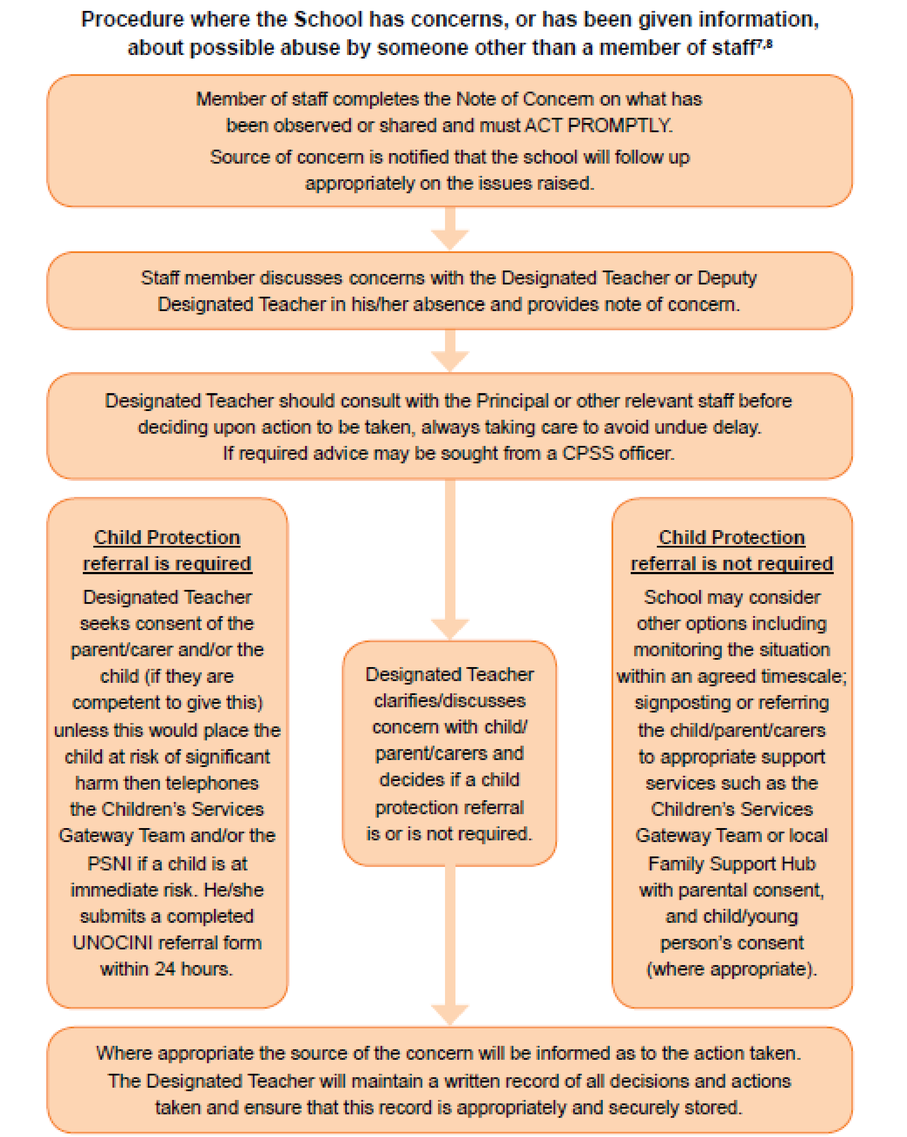

Appendix
4

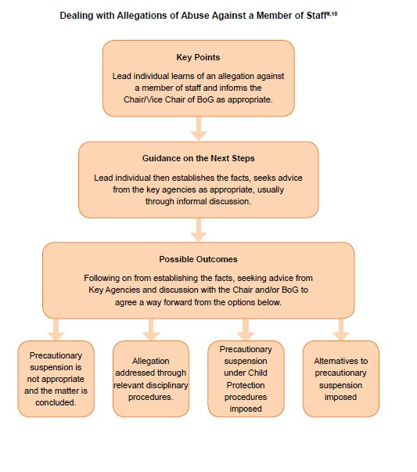
Appendix 5

APPENDIX 6 – OUT OF SCHOOL ACTIVITIES/SCHOOL VISIT - SAMPLE

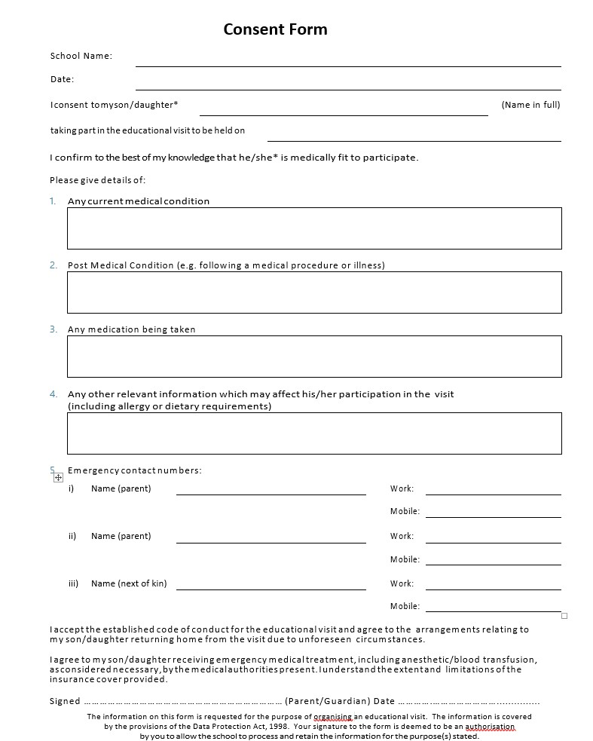

DRUMAHOE PRIMARY SCHOOL

Appendix 7 - GDPR Consent Form for Use of Photographs & Digital Images

Dear Parent,

The use of photographs & digital/video images plays an important part in school activities. Pupils and members of staff may use digital technology to record evidence of activities in lessons in and out of school. These images may then be used in presentations in subsequent lessons.
We believe that celebrating the achievement of children in school is an important part of their learning experience and personal development. Taking photographs/videos of pupils for internal display and displaying pupil work enables us to celebrate individual and group successes as a school community.
Images may also be used to showcase work or celebrate success through their use in classroom and corridor displays, publication in newsletters, on the school website, Facebook page, school app, on the school Twitter feed and occasionally in the public media.

Drumahoe P.S. will comply with the General Data Protection Regulation (GDPR) and will not take or publish images of pupils unless explicit consent has been provided by parents. We are also acutely aware of the importance of e-safety in today’s society and children’s full names will not be published externally with their photographs, but may be published internally (for example, on display with their work).
N.B. Parents/carers are welcome to take videos and digital images of their children at school events (eg. Sports Day, school drama productions etc.) for their own personal use. To respect everyone’s privacy and in some cases protection, these images should not be published/made publicly available on social networking sites, nor should parents/carers comment on any activities involving other pupils in the digital/video images. By signing below, you are providing consent for Drumahoe Primary School to use both hard-copy and digital images (including video) in accordance with how you have completed the tables below in:
- all school publications, on the School App, Website, and on school social media pages;
- in newspapers as approved by the school;
- in videos made by the school or in class for school assemblies/projects etc.

Please read below & tick your preferences before signing and dating the bottom of the form. Please return this form to the school office before <insert date>.
I provide specific consent for photographs or digital images of my child to be used as follows:

Use |  | Yes | No
Using your child’s photograph in printed publications by Drumahoe P.S. This will include the school prospectus, promotional brochures and advertisements etc.
Using your child’s photograph and video footage on our official School App & Website and on our official school’s partnership apps & websites e.g. Shared Education, Highland Dancing etc.
Using your child’s photograph and video footage on our official Facebook page

Using your child’s photograph and video footage on our official Twitter page

Using your child’s photo for publication in approved newspapers

Using photographs and videos of your child within school, and displaying these publicly within the school, as part of the curriculum, assemblies and in class
Using videos of your children to share good practice with professionals from other schools
Pupil’s Name: | Parent Signature: Date:

This consent form covers consent for the duration of your child’s time at the school. If your circumstances change, the onus is on you to inform the school. Once your child leaves the school, photographs and videos may be archived within the school but will not be published without renewed consent.
Yours sincerely

Principal – E Walker B.Ed.

APPENDIX 8 - Acceptable Use Agreement - Staff, Governors & Visitors

ICT and the related technologies such as email, the internet and mobile devices are an expected part of our daily working life in school. This policy is designed to ensure that all members of staff are aware of their professional responsibilities when using any form of ICT. All members of staff are expected to sign this policy and adhere at all times to its contents. Any concerns or clarification should be discussed withMrs S Wheeldon, school UICT/ eSafety Co-ordinator.

- I will only use the school’s email / Internet / Intranet / Learning Platform and any related technologies for professional purposes or for uses deemed ‘reasonable’ by the Principal or Governing Body.  
  
- I will comply with the ICT system security and not disclose any passwords provided to me by the school or other related authorities.
 
- I will ensure that all electronic communications with pupils and staff are compatible with my professional role. 
 
- I will not give out my own personal details, such as mobile phone number and personal email address, to pupils without the prior permission of the Principal or Governing Body.  
 
- I will only use the approved, secure email system(s) for any school business.  
-  
  - I will ensure that personal data (such as data held on SIMS) is kept secure and is used appropriately, whether in school, taken off the school premises or accessed remotely. Personal data can only be taken out of school or accessed remotely when authorised by the Principal or Governing Body.  
 
  - I will not browse, download, upload or distribute any material that could be considered offensive, illegal or discriminatory.  
 
  - Images of pupils and/ or staff will only be taken, stored and used for professional purposes in line with school policy and with written consent of the parent, carer or staff member. Images will not be distributed outside the school network without the permission of the parent/ carer, member of staff or Principal.  
 
  - I understand that all my use of the Internet and other related technologies can be monitored and logged and can be made available, on request, to the Principal. The C2K system tracks all Internet use and records the sites visited. The system also logs emails and messages sent and received by individual users.
 
  - I will respect copyright and intellectual property rights.
-  
  - I will ensure that my online activity, both in school and outside school, will not bring my professional role into disrepute.  
 
  - I will support and promote the school’s e-Safety policy and help pupils to be safe and responsible in their use of ICT and related technologies.  
 
  - I will supervise pupils when they are accessing the Internet. I will check websites before allowing pupils to use them to ensure there is no unsuitable content and that material is age appropriate.

  - I will report deliberate/accidental access to inappropriate materials or any other breaches of the school code of practice immediately to the Principal / ICT Coordinator.

  - I will make pupils aware of the rules for the safe and effective use of the Internet. These will be displayed in the classroom and discussed with pupils.

  - I will not use the school systems for commercial transactions unless deemed
‘reasonable’ by the Principal or Governing Body.  

User Signature

I agree to follow this code of conduct and to support the safe use of ICT throughout the school

Signature……..………………………… Date……………………

Full Name…………………………………………………………………………………
(Printed)

Position…………………………………………………………

APPENDIX 9 – ACCESS TO THE INTERNET (PUPILS)

Using the Internet

Pupil Agreement

I promise that I will use the Internet sensibly and will not use it for the following purposes

- Searching, viewing and/or retrieving materials that are not related to my work in school.

- Playing computer games or using interactive chat sites, unless the teacher has asked me to do so.

- Publishing, sharing or giving out personal information about a user (such as home address, e mail address, phone number, etc)

- Any activity that breaks a school rule.

- Using another user’s password.

- Use of obscene, racist or offensive language.

- Insulting or bullying other people

- Subscribing to any services or ordering any goods.

I know that my teachers can look at the sites I have visited and messages sent or received and if I don’t use it properly my Internet privileges will be suspended.

I know that if something inappropriate happens while I’m using the Internet such as someone that I don’t know asking me for my name and address I need to tell an adult immediately.

Pupil’s Name:___________________________

Signature: ___________________________

Parent: __________________________

ACCESS TO THE INTERNET (PUPILS)

Parents’ Internet Information Letter

Dear Parent/ Carer,

I.C.T. including the internet, email and mobile technologies, etc has become an important part of learning in our school. We expect all children to be safe and responsible when using any I.C.T.

Please read and discuss these e-Safety rules (Pupil Agreement) with your child and complete the slip at the bottom of this page and return it to school promptly. If you have any concerns or would like some explanation please contact the ICT/e-Safety Co-Ordinator, Mrs Wheeldon or the Principal (028-71302284).

I would also ask you to read the Internet Policy of Drumahoe Primary School and the advice that has been given. You will realise that he/she will be able to access telecommunications networks throughout the world using the Internet. You will understand that this access is designed and intended as an educational tool to enhance learning and teaching and that he/she will receive instruction in the appropriate use of this resource.

Please realise that the internet contains material that is sometimes inappropriate for school purposes and by signing the agreement you support Drumahoe Primary School, in explaining to your child that they are responsible for not intentionally accessing such material. Please acknowledge that unacceptable use of the Internet may result in the temporary suspension or withdrawal of privileges and that you will not hold Drumahoe Primary School accountable for unsuitable materials acquired by him/her through Internet usage at school.

Yours sincerely

E Walker MBE
Principal

Drumahoe Primary School - Acceptable Use Agreement:
Pupils/Parent/Carer
We have discussed this and ……………………………………..........(child’s name) agrees to follow the e-Safety rules and to support the safe use of ICT at Drumahoe Primary School.
Parent/CarerSignature…….………………….……………………………………
Child’s Signature……………………………………………………
Class ……… Date ………

APPENDIX 10 – TEMPORARY ADMINISTRATION OF MEDICATION

CONSENT FORM FOR ADMINISTERING MEDICATION IN SCHOOL

Name of Pupil: ______________________________________________________

Class: _____________________________________________________________

Teacher: ___________________________________________________________

I request permission for my son/daughter to be given the following medication during school hours by the class teacher or a designated member of staff.

Medication: __________________________________________________________

Dosage: ____________________________________________________________

When taken: _________________________________________________________

Doctor’s name: __________________________________________________________

Doctor’s telephone number: ________________________________________________

I understand that whilst all best efforts will be made, staff of Drumahoe Primary School accept no responsibility whatsoever for omitting to administer this medicine or administering the medicine at a time different from that specified above.

Signed (Parent/Guardian): ______________________________________________

Date: _______________________________________________________________

Please note that this form relates to temporary administration of medication. Any child requiring ongoing medication requires a personal medical care plan which will be discussed and agreed with the Principal and signed by both parties.

APPENDIX 11: CHANGING PROCEDURES FOR CHILDREN WITH SPECIAL
EDUCATIONAL NEEDS

NAME OF CHILD: ___________________________________________________

STAFF INVOLVED:

Should the above-mentioned child require a nappy change at any time during the session, the following procedures will be followed:

- The Classroom Assistant working with the child will inform the Class Teacher before leaving the classroom with the child;
- The changing procedure will take place using the special facilities in the Disabled toilet;
- There will be two members of staff undertaking this procedure where possible;
- The child will be laid on the changing table for the procedure;
- The Classroom Assistant, wearing the disposable gloves provided, will remove the soiled nappy, clean the child and put on a clean nappy;
- The soiled nappy will be disposed of in the appropriate bin in the changing area.
- Both staff members and child will then wash and dry their hands;
- The time of changing will be recorded and signed by both members of staff;
- The child and staff members will return to class immediately following this procedure and inform a member of staff of their return.

We, the above-mentioned, have read the procedures to be followed and are happy with the arrangements and agree to follow them.

I, the parent / guardian of _____________________________________________ am happy for the above-named staff to change my child, following the above procedures.

Parent / Guardian ____________________________________

Date: ____________________________________

SEN INTIMATE CARE RECORD SHEET

NAME OF CHILD: ___________________________________________________

Date | Time | Nature of care | Adult's Signature 1 | Adult's Signature 2

Intimate Care Record

To be completed each time a child requires a change of clothing due to an incident such as wetting and/or soiling themselves or being physically sick.

Date | Time | Initials of  Pupil | Class | Incident  (W, S, V) | Action Taken  (Other  Comments) | Staff  Involved | Signed

Appendix 12: The School Safeguarding Team - Roles & Responsibilities

Chair of the Board of Governors

The Chair of the Board of Governors is responsible for:
- Ensuring that a Child Protection policy is in place and that a safeguarding ethos is maintained in the school;
- Ensuring that a Designated Governor for Child Protection is appointed;
- Ensuring that Governors receive relevant training in Child Protection and Recruitment and Selection;
- Assuming lead responsibility in the management of a complaint/allegation against the School Principal;
- Ensure that the Board of Governors receive regular updates in relation to child protection activity including a full written annual report.

Designated Governor for Child Protection

The Designated Governor is responsible for advising the Governors on matters related to child protection including the child protection policy, reports to Governors, the recruitment, selection and vetting of staff and the role of the Designated Teacher.

Principal

The Principal is responsible for:
- Ensuring that all relevant DENI guidance in relation to child protection and safeguarding in particular “Pastoral Care in Schools – Child Protection” (1999) is implemented within the school;
- Enabling the Board of Governors fulfil their Child Protection duties by keeping them informed of any changes to guidance, procedure or legislation relating to child protection and ensuring the inclusion of child protection activities on their agenda;
- Maintaining and securely storing the School Record of Child Abuse Complaints and to make it available at least annually to the Board of Governors;
- The appointment of suitable staff to posts (teaching and non-teaching) within the school and the appointment of suitable teaching staff to the roles of Designated and Deputy Teacher for Child Protection;
- Ensuring that parents and pupils receive a copy of the Child Protection Policy and Complaints Procedures every 2 years;
- Managing child protection concerns relating to staff.

Designated and Deputy Designated Teacher for Child Protection

Every school is required to appoint a Designated Teacher with responsibility for Child
Protection. They must also appoint a Deputy Designated Teacher who as a member of the Safeguarding team will actively support the Designated Teacher in carrying out the following duties:

- Providing child protection training for all teaching and non-teaching staff (whole school training) to be delivered a minimum of once every two years;
- Taking lead responsibility for the development and annual review of the school’s child protection policy;
- Promoting a child protection ethos in the school;
- Acting as a point of contact for staff (and parents) in relation to child abuse concerns;
- Liaison with the Principal and Education Authority’s Designated Officers for Child
Protection in cases of suspected Child Abuse;
- Making referrals to other agencies, with the Principal’s knowledge;
- Maintaining and securely storing appropriate child protection records;
- Attending child protection case conferences and other relevant case planning meetings where appropriate and practicable;
- Providing an annual report to the Governors on child protection activity.

The Deputy Designated Teacher will deputise for them in their absence.

Appendix 13: Child Protection Record – ‘Note of Concern’.

CONFIDENTIAL
NOTE OF CONCERN (Child Protection)

Name of Pupil:

Year Group:

Date, time of incident/disclosure:

Circumstances of incident/disclosure:

Nature of description of concern (Use ‘Body Map Template’ if necessary):

Parties involved, including any witnesses to an event and what was said or done and by whom.

Action taken at time:

Details of any advice sought, from whom and when:

Any further action taken:

Yes |  | No
Written report passed to Designated Teacher If ‘No’ state reason.

Date and time of report to the Designated Teacher

Written note from staff member placed on pupil’s Child Protection file.
Yes |  | No
If ‘No’ state reason.

Name of member of staff making report ………………………………………..

Signature of staff member……………………………… Date: …………….

Signature of Designated Teacher: ……………………Date: ………

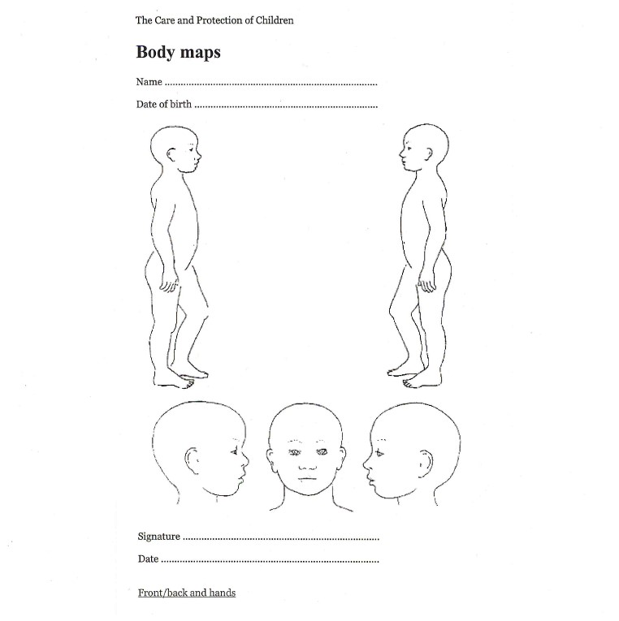

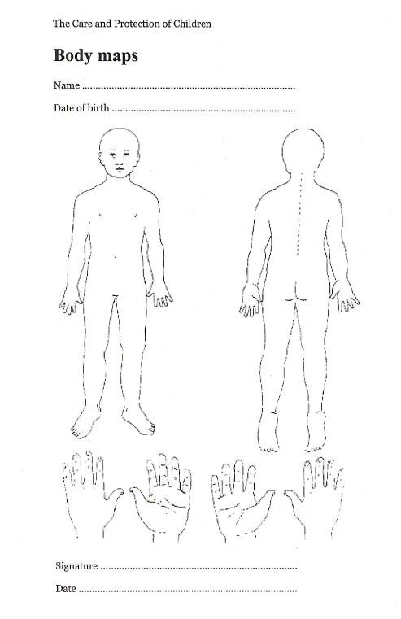

Appendix 14

Types of Abuse and Physical/Behavioural Indicators

Neglect is the failure to provide for a child’s basic needs, whether it be adequate food, clothing, hygiene, supervision or shelter that is likely to result in the serious impairment of a child’s health or development. Children who are neglected often also suffer from other types of abuse.
(Co- operating To Safeguard Children and Young People in Northern Ireland 2016)

Physical Indicators | Behavioural Indicators
Looks very thin, poorly and sad; constant hunger; lack of energy;  untreated medical problems; special needs of child not being met; constant tiredness; inappropriate dress; poor hygiene; repeatedly unwashed;  smelly;  repeated accidents, especially burns. | Tired or listless (falls asleep in class); steals food; compulsive eating; begging from class friends; withdrawn; lacks concentration; misses school medicals; reports that there is no carer is at  home; low self-esteem;  persistent non-attendance at school; exposure to violence including unsuitable videos.

Physical Abuse is deliberately physically hurting a child. It might take a variety of different forms, including hitting, biting, pinching, shaking, throwing, poisoning, burning or scalding, drowning or suffocating a child.
(Co- operating To Safeguard Children and Young People in Northern Ireland 2016)

Physical Indicators | Behavioural Indicators
Unexplained bruises – in various  stages of healing; grip marks on arms; slap marks; human bite marks; welts; bald spots;  unexplained/untreated burns; especially cigarette burns (glove like);  unexplained fractures; lacerations or abrasions; untreated injuries;  bruising on both sides of the ear – symmetrical bruising should be treated with suspicion;  injuries occurring in a time pattern e.g. every Monday | Self-destructive tendencies; aggression to other children; behavioural extremes (withdrawn or aggressive);  appears frightened or cowed in presence of adults; improbable excuses to explain injuries; chronic runaway; uncomfortable with physical  contact; coming to school early or staying last as if afraid to be at home; clothing inappropriate to weather – to hide part of body;  violent themes in art work or stories

Emotional Abuse is the persistent emotional maltreatment of a child. It is also sometimes called psychological abuse and it can have severe and persistent adverse effects on a child’s emotional development. Emotional abuse may involve deliberately telling a child that they are worthless, or unloved and inadequate. It may include not giving a child opportunities to express their views, deliberately silencing them, or ‘making fun’ of what they say or how they communicate. Emotional abuse may involve bullying – including on-line bullying through social networks, on-line games or mobile phones – by a child’s peers. (Co- operating To Safeguard Children and Young People in Northern Ireland 2016)

Physical Indicators | Behavioural Indicators
Well below average in height and weight;  “failing to thrive”; poor hair and skin; alopecia;  swollen extremities i.e. icy cold and  swollen hands and feet;  recurrent diarrhoea, wetting and soiling;  sudden speech disorders; signs of self-mutilation; signs of solvent abuse (e.g. mouth sores, smell of glue, drowsiness); extremes of physical, mental and emotional development (e.g. anorexia, vomiting, stooping). | Apathy and dejection; inappropriate emotional responses to painful situations; rocking/head banging;  inability to play;  indifference to separation from family indiscriminate attachment; reluctance for parental liaison; fear of new situation; chronic runaway; attention seeking/needing behaviour; poor peer relationships.

Sexual Abuse occurs when others use and exploit children sexually for their own gratification or gain or the gratification of others. Sexual abuse may involve physical contact, including assault by penetration (for example, rape, or oral sex) or non-penetrative acts such as masturbation, kissing, rubbing and touching outside clothing It may include non-contact activities, such as involving children in the production of sexual images, forcing children to look at sexual images or watch sexual activities, encouraging children to behave in sexually inappropriate ways or grooming a child in preparation for abuse (including via e-technology). Sexual abuse is not solely perpetrated by adult males. Women can commit acts of sexual abuse, as can other children.
(Co- operating To Safeguard Children and Young People in Northern Ireland 2016)

Physical Indicators | Behavioural Indicators
bruises, scratches, bite marks or other injuries to breasts, buttocks, lower abdomen or thighs;  bruises or bleeding in genital or anal areas; torn, stained or bloody underclothes; chronic ailments such as recurrent  abdominal pains or headaches; difficulty in walking or sitting; frequent urinary infections; avoidance of lessons especially PE, games, showers; | What the child tells you; Withdrawn; chronic depression;  excessive sexual precociousness; seductiveness; children having knowledge beyond their usual frame of reference e.g. young child who can describe details of adult sexuality; parent/child role reversal;  over concerned for siblings; poor self-esteem;
unexplained pregnancies where the identity of the father is vague; anorexia/gross over-eating. | self-devaluation; lack of confidence; peer problems; lack of involvement; massive weight change; suicide attempts (especially adolescents); hysterical/angry outbursts; lack of emotional control; sudden school difficulties e.g. deterioration in school work or behaviour;  inappropriate sex play; repeated attempts to run away from home; unusual or bizarre sexual themes in children’s art work or stories;  vulnerability to sexual and emotional exploitation; promiscuity;  exposure to pornographic material

Exploitation is the intentional ill-treatment, manipulation or abuse of power and control over a child or young person; to take selfish or unfair advantage of a child or young person or situation, for personal gain. It may manifest itself in many forms such as child labour, slavery, servitude, engagement in criminal activity, begging, benefit or other financial fraud or child trafficking. It extends to the recruitment, transportation, transfer, harbouring or receipt of children for the purpose of exploitation. Exploitation can be sexual in nature.

Although ‘exploitation’ is not included in the categories of registration for the Child Protection Register, professionals should recognise that the abuse resulting from or caused by the exploitation of children and young people can be categorised within the existing CPR categories as children who have been exploited will have suffered from physical abuse, neglect, emotional abuse, sexual abuse or a combination of these forms of abuse.
(Co- operating To Safeguard Children and Young People in Northern Ireland 2016)

A child may suffer or be at risk of suffering from one or more types of abuse and abuse may take place on a single occasion or may occur repeatedly over time.

Child Abuse in Other Specific Circumstances

Bullying
Bullying is not defined as a category of abuse within the Area Child Protection Committees’ Regional Policy and Procedures (2005). The policy does however state that the damage inflicted by bullying behaviour can frequently be underestimated. It can cause considerable distress to children and at the extreme cause them significant harm (including self-harm).
The procedure for referral and investigation of abuse may therefore be implemented in certain circumstances such as when anti-bullying procedures have failed to be effective; the bullying behaviour is persistent and severe resulting in the target of the bullying suffering/likely to suffer significant harm; there are concerns that the bullying behaviour is indicative of the child exhibiting this behaviour suffering/likely to suffer significant harm or where concerns exist in relation to the parents/carer’s capacity to meet the needs of the child (either the target or the child exhibiting this behaviour).

Children Who Sexually Abuse Others or Display Sexually Harmful Behaviour
When abuse of a child is alleged to have been carried out by another child, the procedures outlined in the section on Procedures for Reporting Suspected or Disclosed Child Abuse of this policy will be followed. It is important in such situations to distinguish between behaviours which are experimental in nature and those that are exploitative and harmful. Advice and support will be sought in such circumstances from the Education Authority’s Designated Officer for Child Protection and where appropriate a referral made to the statutory agencies. In all such cases a risk assessment will be undertaken and an individual support and safety plan identified. Appropriate services will also be provided for the children involved. The above guidance follows DE Circular 2016/05 subject Children Who Display Harmful Sexualized Behaviour.

Child Sexual Exploitation
‘Child sexual exploitation is a form of sexual abuse where children are sexually exploited for money, power or status. It can involve violent, humiliating and degrading sexual assaults. In some cases, young people are persuaded or forced into exchanging sexual activity for money, drugs, gifts, affection or status. Consent cannot be given, even where a child may believe they are voluntarily engaging in sexual activity with the person who is exploiting them. Child sexual exploitation doesn't always involve physical contact and can happen online. A significant number of children who are victims of sexual exploitation go missing from home, care and education at some point.’
(Co- operating To Safeguard Children and Young People in Northern Ireland 2016)

The key factor that distinguishes cases of CSE from other forms of child sexual abuse is the concept of exchange – the fact that someone coerces or manipulates a child into engaging in sexual activity in return for something they need or desire and/or for the gain of those perpetrating or facilitating the abuse. The something received by the child or young person can include both tangible items and/or more intangible ‘rewards’ or ‘benefits’ such as perceived affection, protection or a sense of value or belonging.

Any child under the age of eighteen, male or female, can be a victim of CSE, including those who can legally consent to have sex. The abuse most frequently impacts upon those of a post-primary age and can be perpetrated by adults or peers, on an individual or group basis.

The potential indicators of CSE can include, but are not limited to:

- Acquisition of money, clothes, mobile phone etc. without plausible explanation;
- Leaving home/care without permission;
- Persistently going missing or returning late;
- Receiving lots of texts/phone calls prior to leaving;
- Agitated/stressed prior to leaving home/care;
- Returning distraught/ dishevelled or under the influence of substances;
- Requesting the morning after pill upon return;
- Truanting from school;
- Inappropriate sexualised behaviour for age;
- Physical symptoms or infections e.g. bruising, bite marks, sexually transmitted infections;
- Concerning use of the internet;
- Entering or leaving cars driven by unknown adults or by taxis;
- New peer groups;
- Significantly older ‘boyfriend’ or ‘girlfriend’;
- Increasing secretiveness around behaviours;
- Low self-esteem;
- Change in personal hygiene (greater attention or less);
- Self harm and other expressions of despair;
- Evidence or suspicion of substance misuse.

Whilst these indicators can be usefully used to identify potential risk, it is important to note that their presence does not necessarily mean that CSE is occurring. More importantly, nor does their absence, mean that it is not.

Indecent Photographs
The offence of taking indecent pictures of children under 18 years can apply in a situation where a pupil has taken an indecent picture using a mobile phone of others under 18 years of age. It is also an offence to distribute, possess with intent to distribute or show such photographs to others. In such circumstances the PSNI and Social Services will be contacted. The school also has an e-safety/ mobile phone and electronic devices (or similarly named policies) which has/have been circulated to parents and pupils and which is available from the school.

Young Person whose Behaviour places him/her at Risk of Significant Harm
A child whose own behaviours e.g. self-harming behaviour, leaving school without permission etc. places him/her at risk of significant harm, may not necessarily constitute abuse as defined in Area Child Protection Committees’ Regional Policy and Procedures (2005). The decision to initiate child protection procedures is a matter for professional judgement and each case will be considered individually with advice sought from the Education Authority’s Designated Officer for Child Protection. The criminal aspects of such cases will be dealt with by the PSNI.

Domestic Violence and Abuse

Is defined as threatening, controlling, coercive behaviour, violence or abuse (psychological, virtual, physical, verbal, sexual ,financial or emotional) inflicted on anyone (irrespective of age, ethnicity, religion, gender, gender, identity, sexual orientation or any form of disability) by a current or former intimate partner or family member.’
(Stopping Domestic and Sexual Violence and Abuse in Northern Ireland A Seven Year Strategy: March 2016)

Sexual Violence and Abuse

Is defines as ‘any behaviour (physical, psychological, verbal, virtual /online ) perceived to be of a sexual nature which is controlling, coercive, exploitative, harmful or unwanted that is inflicted on anyone (irrespective of age, ethnicity, religion, gender, gender identity, sexual orientation or any form of disability).’

Please note that coercive, exploitative and harmful behaviour includes taking advantage of an individual’s incapacity to give informed consent.
(Stopping Domestic and Sexual Violence and Abuse in Northern Ireland A Seven Year Strategy: March 2016)

A child may live in a family where there is domestic abuse or a young person may be in a relationship where they become the subject of domestic abuse. In high risk cases involving domestic abuse Social Services and/or the Education Authority’s Designated Officer for Child Protection will contact the school in order to help assess the child/young person’s needs and to ensure that he/she is receives appropriate support.

KEY CONTACT NUMBERS

CHILD PROTECTION SUPPORT SERVICE Tel: 028-95985590
EDUCATION AUTHORITY WESTERN REGION
Designated Officer for Child Protection
1 Hospital Road Omagh
Tel: 028 82411480

WESTERN HEALTH & SOCIAL CARE TRUST
Gateway Team, Whitehill,
106 Irish Street, Londonderry
Tel: 028-71314090

PSNI
Central Referral Unit (CRU) – for child sexual & physical abuse allegations. Tel: 028- 90259299

